IMT Worksheet 1

All your answers should be in a word document saved in a Git repository under your username. Submit your answers by sending a link to your git repository as a reply to your email.

Define the following concepts using screenshots and text:

* Repository

Both Git and GitHub refer to this as a repository, or “repo” for short, a digital directory or storage space where you can access your project, its files, and all the versions of its files that Git saves.

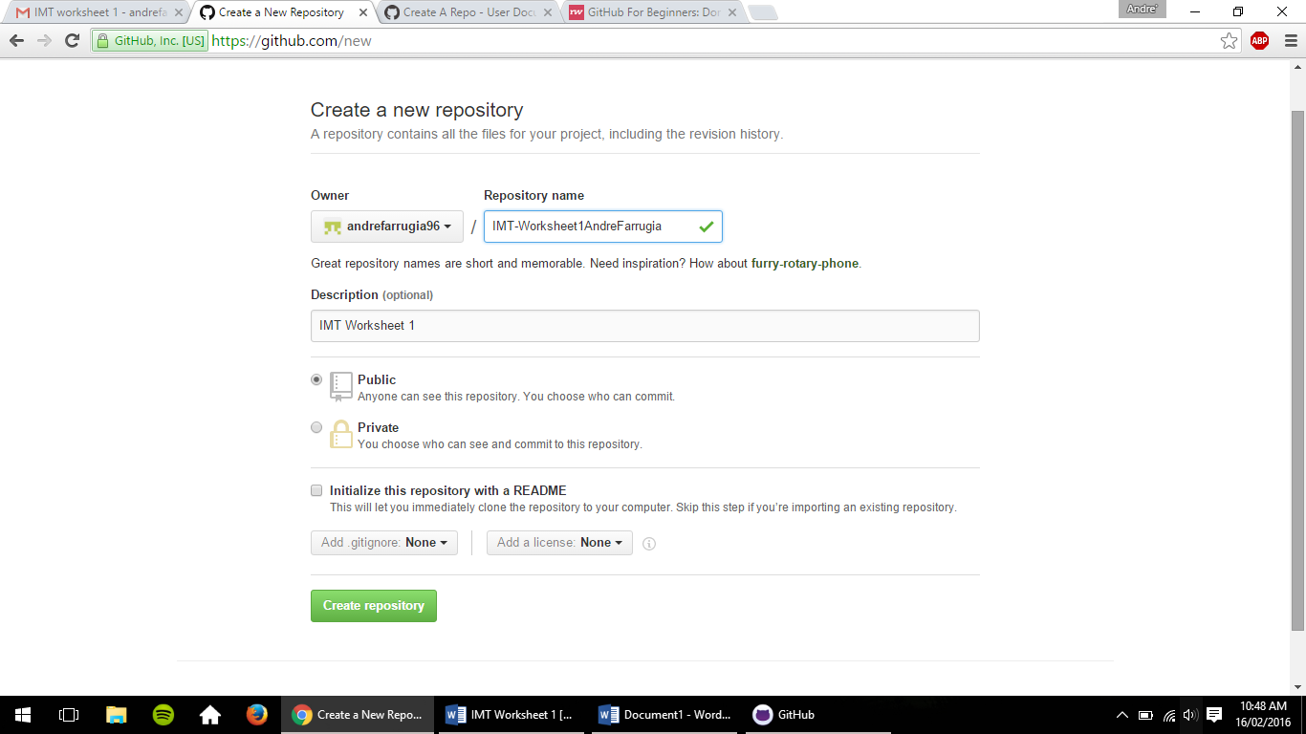

* Commit

A commit, or "revision", is an individual change to a file (or set of files). It's like when you save a file, except with Git, every time you save it creates a unique ID (a.k.a. the "SHA" or "hash") that allows you to keep record of what changes were made when and by who. Commits usually contain a commit message which is a brief description of what changes were made.

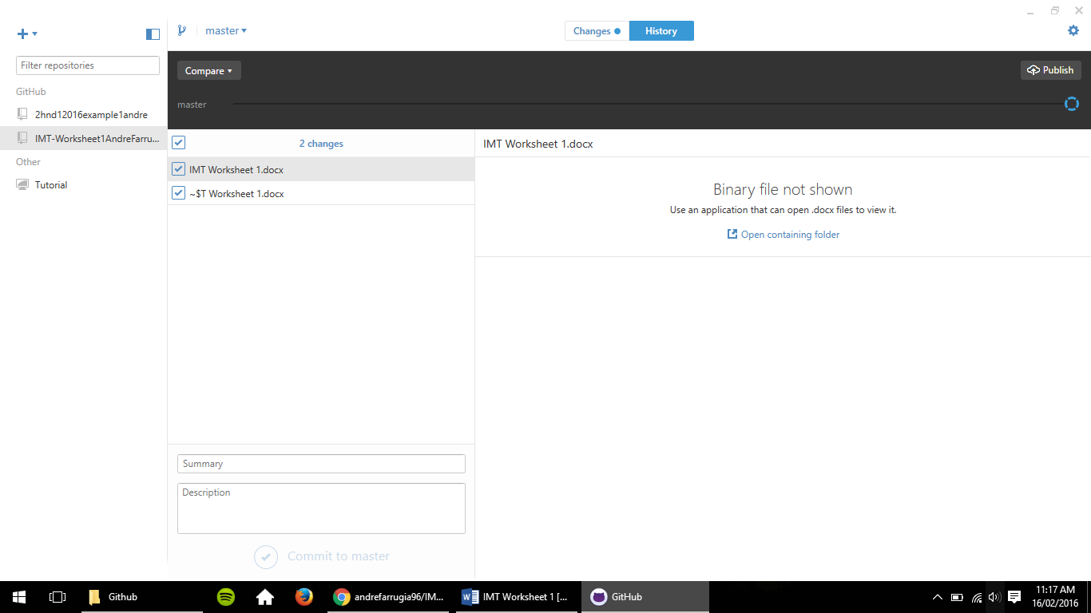

* Commit description

The commit description is when the user can add a description to his files being stored on that particular repository. This is a very useful way to keep your files more organized.



* Github desktop

This is the GitHub desktop. GitHub Desktop is a unified way to contribute to projects on GitHub. GitHub is also available for Mac and Windows.

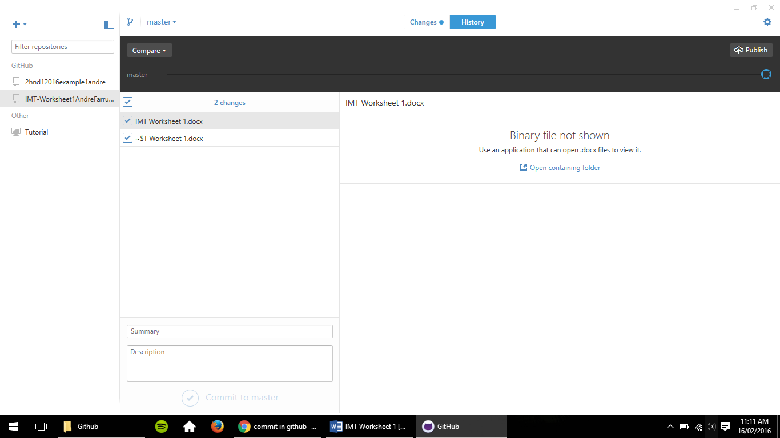

* Git Sync

Git Sync is used so that all data stored in that repsoitory will be synced online.

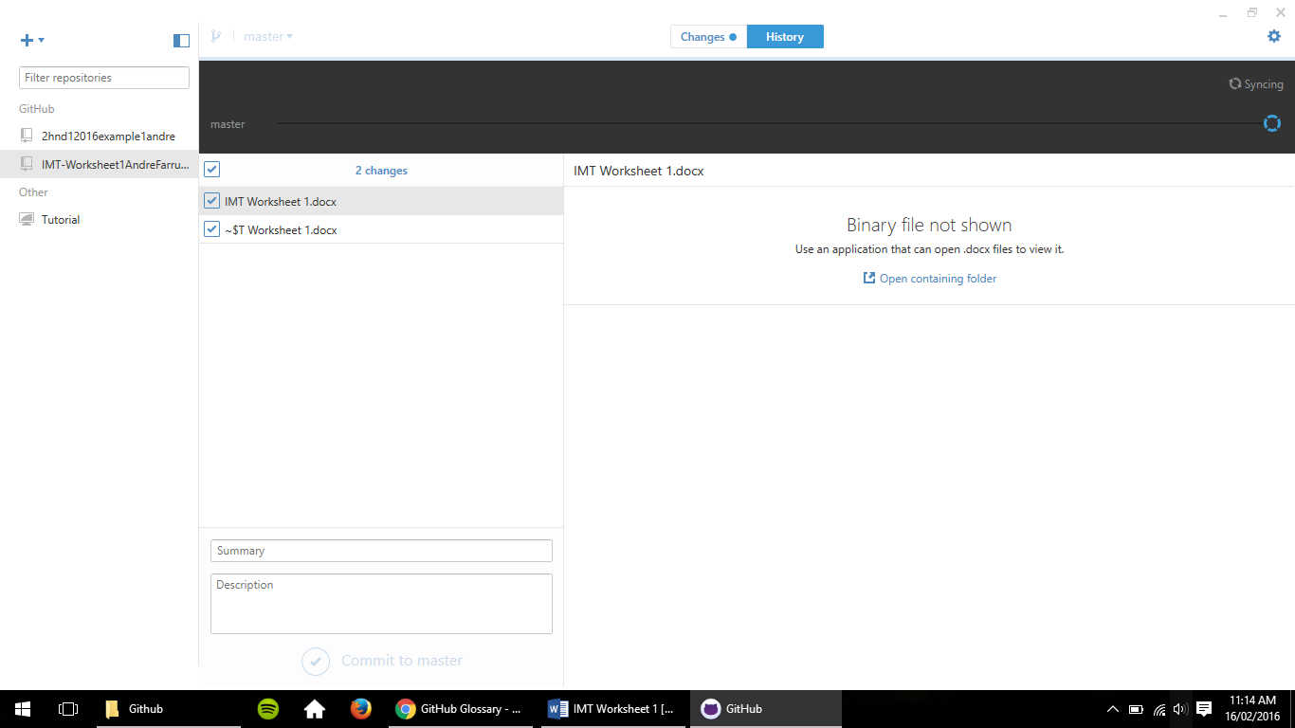

* What ‘download zip’ does.

On every project there’s an easy to use ‘Download as ZIP’ button that will give you the entire contents of the project. Meaning the user can download files through this button. It is important to keep in mind that some files may not be available to others because it may not be set to public.

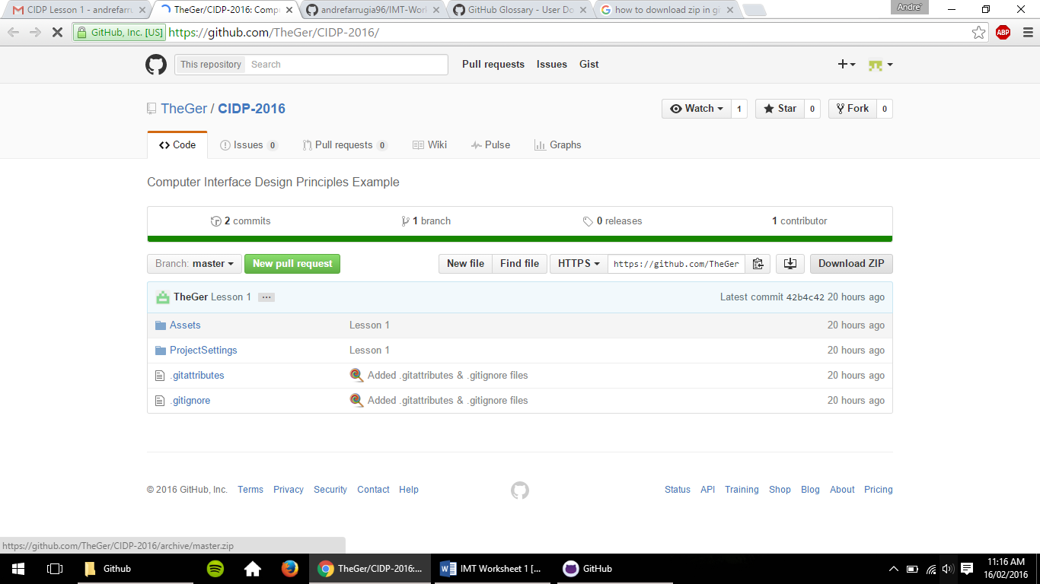

Create a word document and sync it to your Git repository.